**Mac client installation and configuration**

**Installation**

1. Insert the ElecRoc Install DVD into the DVD-ROM. Find out **ElecRoc6.0.pkg**in the install directory \Client\MAC\.

**Note:**If you access the install file***ElecRoc6.0.pkg***through a network sharing instead of an install DVD, we recommend you to copy this file to your local computer before you run it to start the installation.

2. Double-click to run the install program. The program first displays the welcome window.

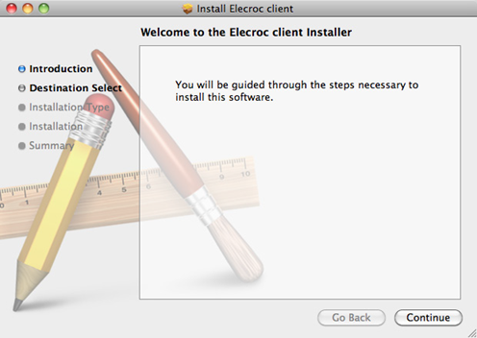

3. Click **Continue**. The **Destination Select** dialog appears. Select the destination folder and click **Continue**.

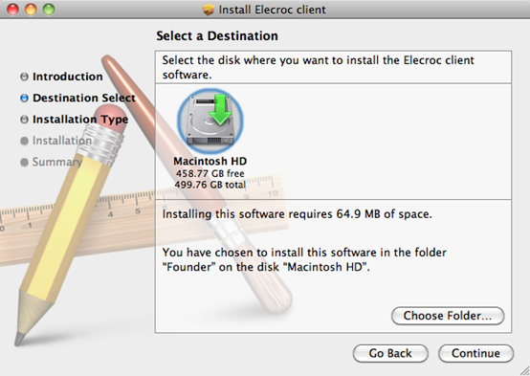

4. The **Installation Type** dialog will be displayed. Click **Install** to begin the installation.

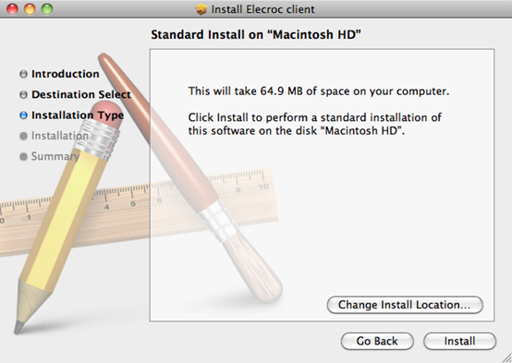

5. A dialog box may appear and ask you to provide an operating system administrative user and password (if any).

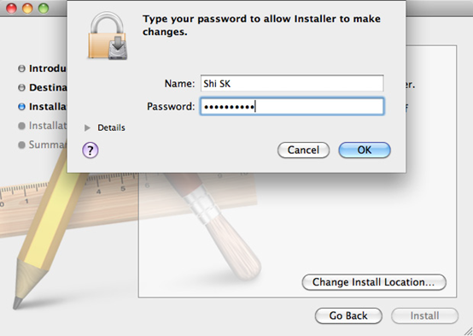

6. The **Installation**window appears, showing the install progress with a bar.

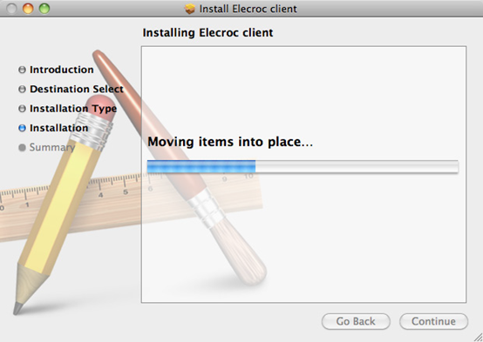

7. When the progress bar reaches 100%, the following dialog shows that the installation was successful. Click **Close**to complete.

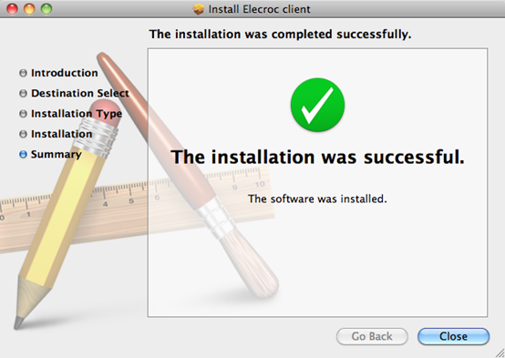

**Configuration**

1.     Open Mac client software, you can get Mac computer name from the server item, see the next image, computer name is “DrupaMac.local”.

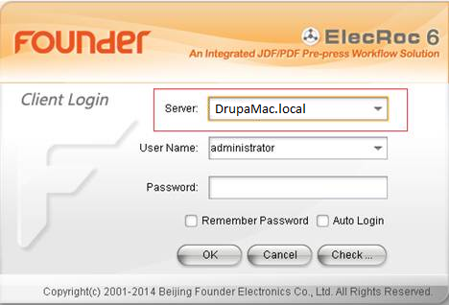

Or you can get Mac computer name from “terminal” utilities, see the next step:

A. run “Terminal” in “Go”—“Utilities”

B. type **uname–n**, you can get computer name, see the next image, the computer is “DrupaMac.local”

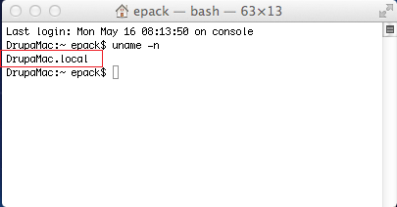

2.     Run ElecRoc Server, and click “Settings”---“Authorization”, in the next windows, add Mac computer name to the list.

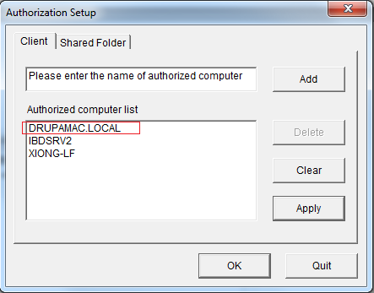

3.     In Mac client login windows, input Server computer IP in “Server” item, then click“Check”.

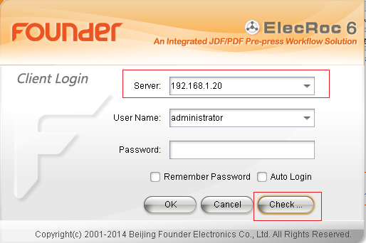

4.     In the next windows, click “Start”, it will check the result of  connection with Server.

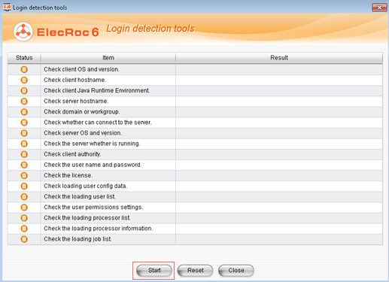

5.     If the result is ok, follow the next step to map server name to IP address,

a)       run “Terminal”

b)       type**cd/**

c)       type **cd etc**

d)       type **sudo vi hosts**

e)       input **password**, then press “return” key.

         attention, when input pw, nothing happen inwindow, don’t care about that, just finish input and return

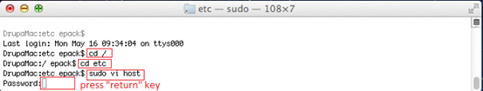

f)        there appear host database window

g)       type**i**to enable input in this window

h)       move input symbol under ::1 localhost

i)         type **IP address of PC, space, PC computer name**---attention, the format should be sameas upper

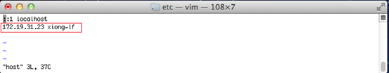

j)         press “esc”key

k)       type **:wq** to save and quit

l)         quit terminal

m)    ping PC with computer name, if it isn’t ok, check Server computer name and IP address.

6.     run ElecRoc client and logon with computer name.

Notes:

1     Don’t install any anti-virus software.

2     Set a fixed IP address.

3     Don’t change the computer name after server has been installed.